ETRAC – Creating a Graphic Report
Using the data that you have collected in ETRAC, there are many options for presenting your information to others. One of the most clearly understood methods for showing information is via charts and graphs, which makes it easier to show the results of your risk tree assessment to an audience. Using the graphing and charting capabilities of Microsoft Excel, which is able to access the database archive software used in ETRAC, it is very easy to create visually effective graphics for your use.
Since there are a number of versions of Excel available for a variety of operating systems, it is best to use the help menu in your particular Excel edition, in order to fully access the specific details related to creating a chart or graph in your version of the software.
An example of how to create a graphic report with ETRAC data, using Excel is illustrated below; however, this is only an example. Please check on the graphing and charting capabilities of your version by accessing the Help menu.EXAMPLE #1 – Creating a Pie Chart of the Numbers of Trees and Risk Rating
Step 1 – Export your E-TRAC data to an Excel-compatible “CSV’ file.
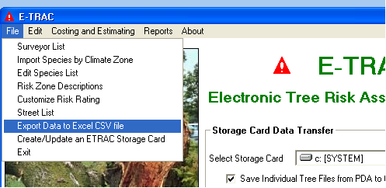
Decide on the range for survey dates you wish to include and create the CSV file.
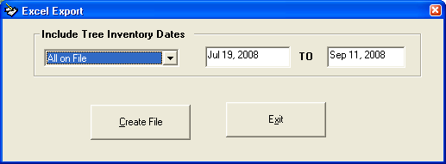

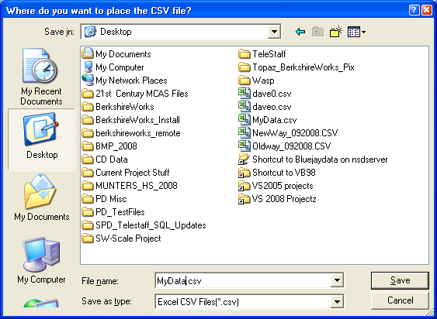
Step 2 – Locate the CSV file you just created and DOUBLE CLICK it. It will open as an Excel worksheet.
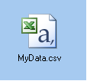
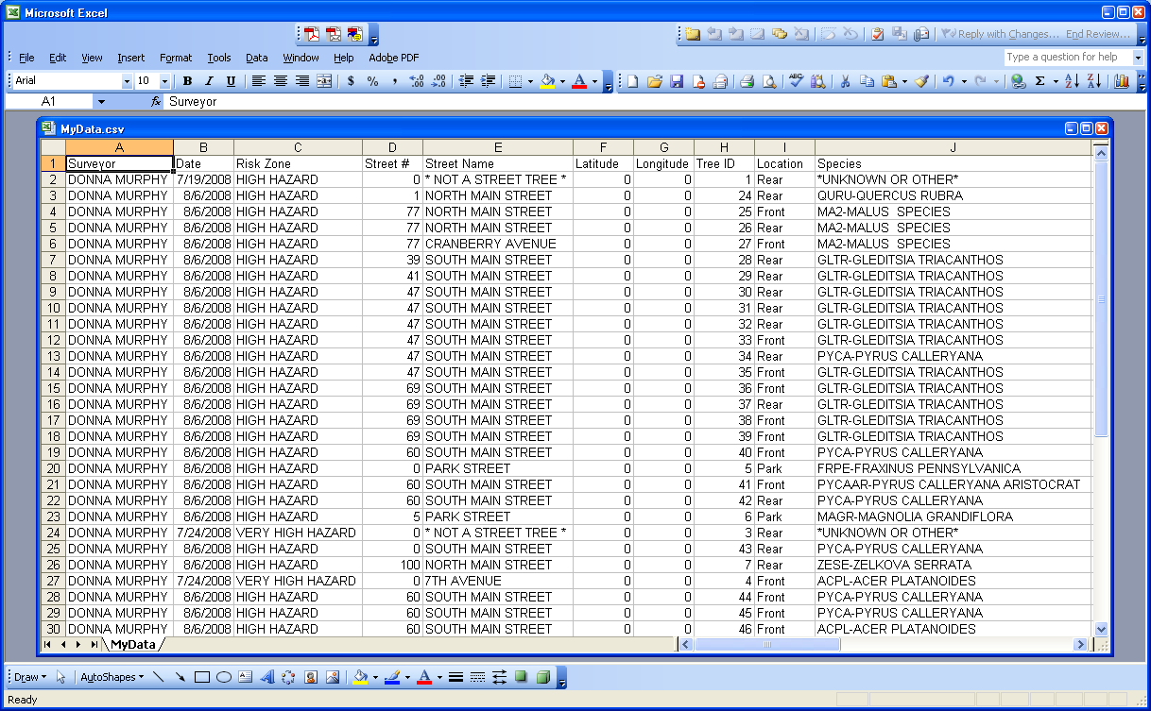
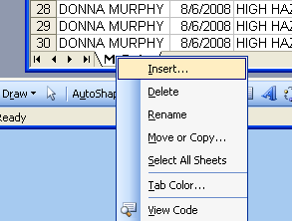
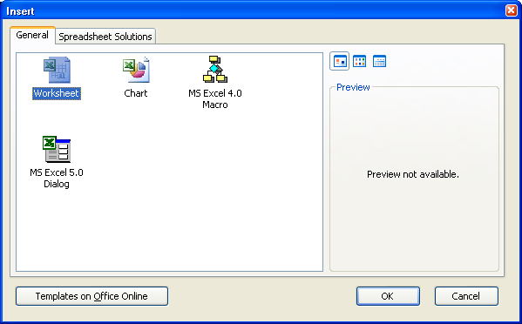
Step 3 – RIGHT click on the tab at the bottom of the spreadsheet and create a new Worksheet to hold your graph.

]

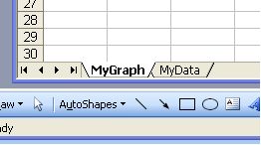
RIGHT Click on your new TAB and rename it to something that is meaningful for you.

Go back to the original tab which holds your imported Tree data and scroll over to the “Risk Rating” column.

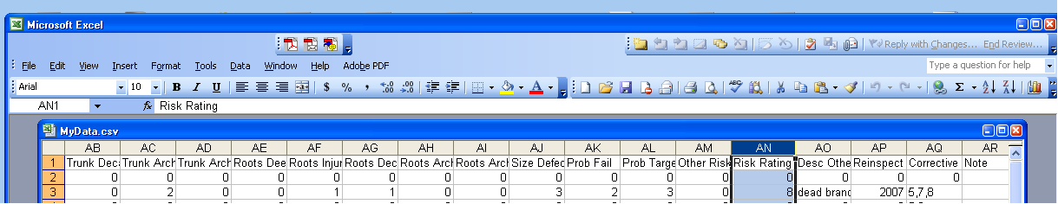

Note the RANGE for this column. In our Example, it is AN2:AN50.

Now, go back to your new GRAPH worksheet.

Decide on which Risk Rating scores you wish to count in your graph. In our example, we will use 0, 4, 5,6,7,8, and 10.

Create entries in your Graph worksheet with the target Risk Ratings.
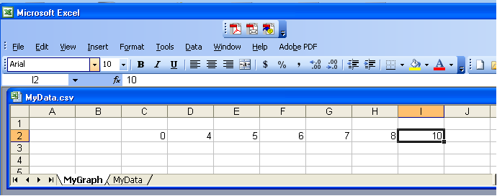

Create a formula below each target risk rating to count the number of occurrences of that Rating in Column “AN” in your data worksheet. The Excel “COUNTIF()” function works very well here

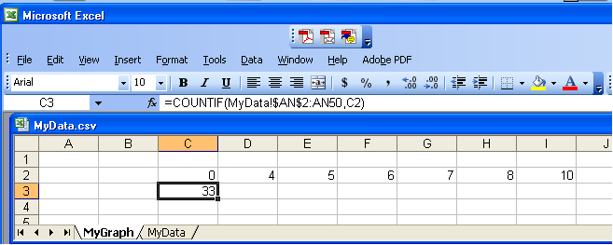

Grab the lower right corner of Cell C3 and drag it across all the columns. If you constructed your formula properly, you will now have counts for each of the risk ratings from the data worksheet.

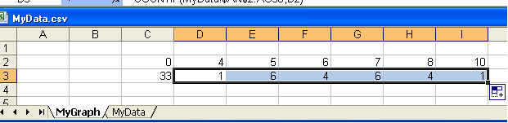

Insert a chart

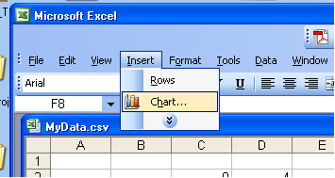

Select the options as shown below.

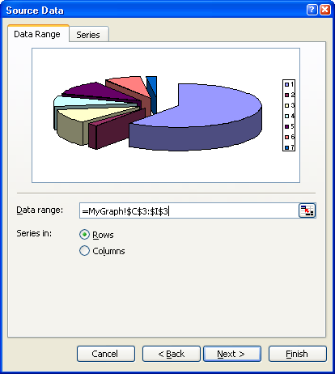
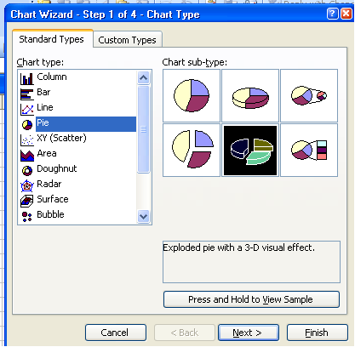

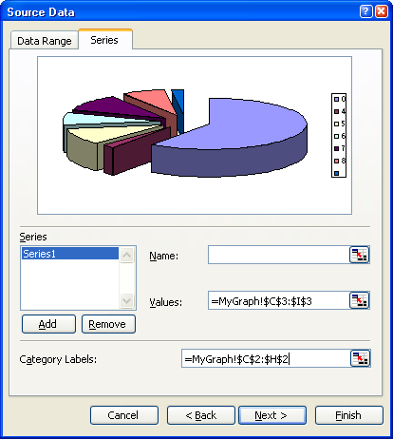

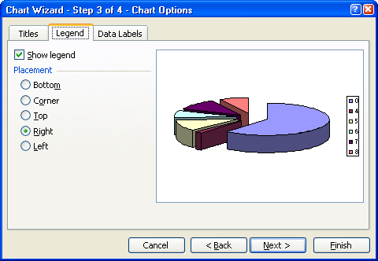

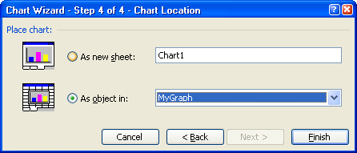

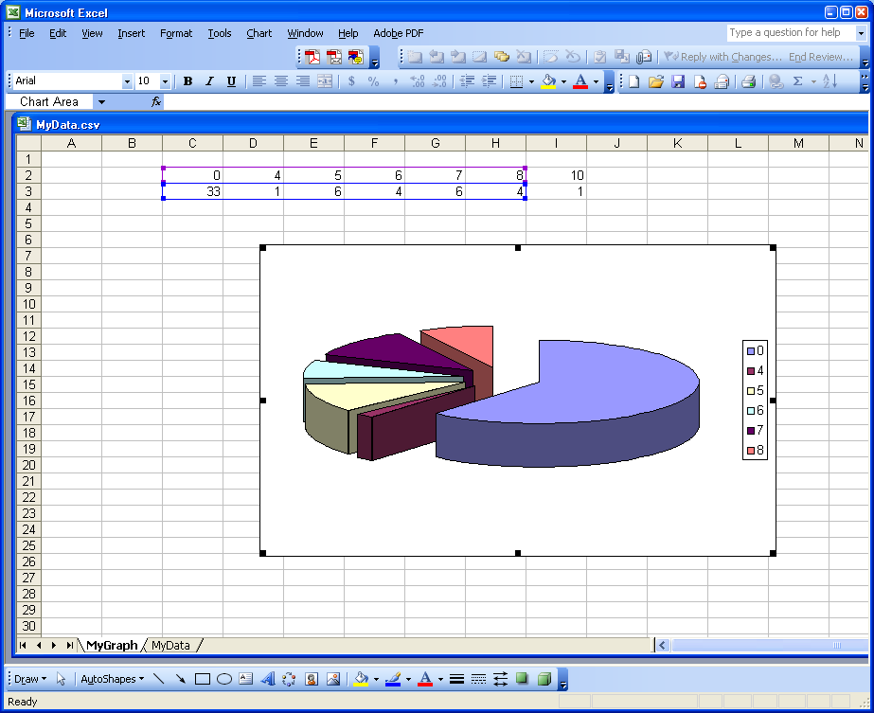

You can enhance the appearance of your graph in a number of ways. For example, if you RIGHT CLICK on the chart
Add a title

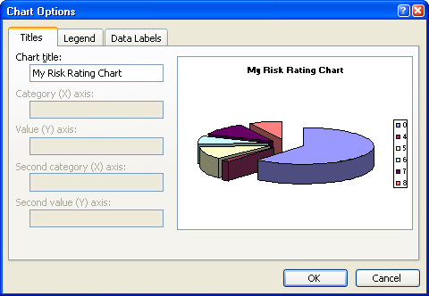

Add data labels to show the percentage of each Risk Rating in your sample.

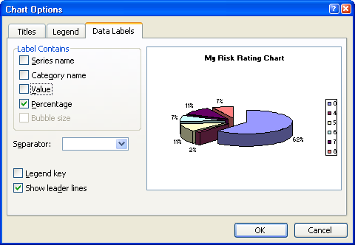

Tilt the 3-D Graph to a different viewing angle.
